Rajshahi university of Engineering & Technology



***CSE 4104***

***LAB REPORT-01***

DATE: 26.04.2021 B.Sc.Engg.,RUET

**UTSHAB KUMAR GHOSH *Submitted to-***

*DEPT.: CSE , SECTION: A* ***MD. ASIFUR RAHMAN* sir**

*ROLL: 1603022**LECTUREr*

**Problem:** Basic Signal Operations.

DATE: 20.01.2020 B.Sc.Engg.,RUET

**x(n) = {…, 0, 1, 2, 3, 4, 5, 4, 3, 2, 1}**. Find out:

1. **y(n) = x(n – 2) + x(n + 3)**
2. **y(n) = x(2n – 2) + x(n + 3)**

**Hand written Work:**

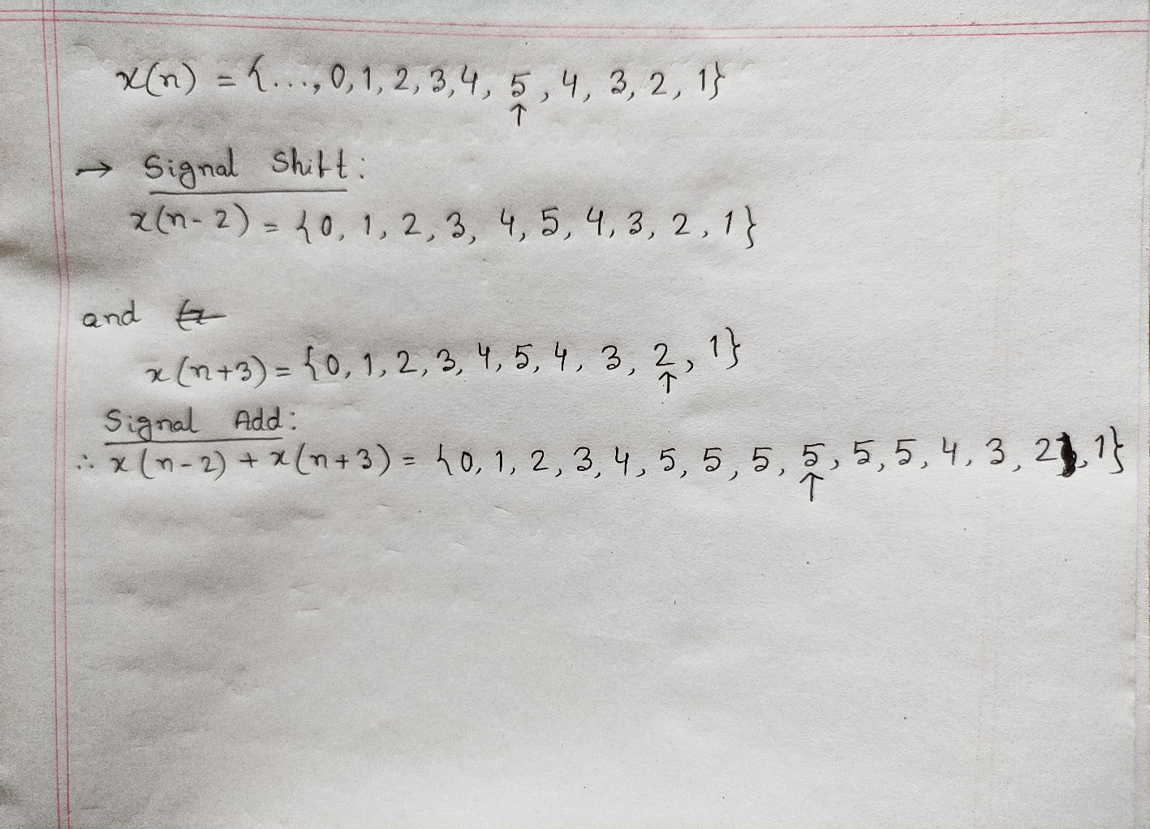

**Code Snippets:**

**main.m:**

% y(n) = x(n-2) + x(n+3)

n =[-5:4];

x = [0:5,4:-1:1];

[x11, n11] = sigshift(x,n,2);

[x12, n12] = sigshift(x,n,-3);

[x1,n1] = sigadd(x11,n11, x12,n12);

subplot(2,1,1);

stem(n1,x1);

xlabel('n');

ylabel('y(n)');

**sigshift.m:**

function [y,n] = sigshift(x,m,k)

% implements y(n) = x(n-k)

% -------------------------

% [y,n] = sigshift(x,m,k)

%

n = m+k; y = x;

**sigadd.m:**

function [y,n] = sigadd(x1,n1,x2,n2)

% implements y(n) = x1(n)+x2(n)

% -----------------------------

% [y,n] = sigadd(x1,n1,x2,n2)

% y = sum sequence over n, which includes n1 and n2

% x1 = first sequence over n1

% x2 = second sequence over n2 (n2 can be different from n1)

%

n = min(min(n1),min(n2)):max(max(n1),max(n2)); % duration of y(n)

y1 = zeros(1,length(n)); y2 = y1;

y1(find((n>=min(n1))&(n<=max(n1))==1))=x1;

y2(find((n>=min(n2))&(n<=max(n2))==1))=x2;

y = y1+y2;

**Output:**

